Portfolio Returns Calculation
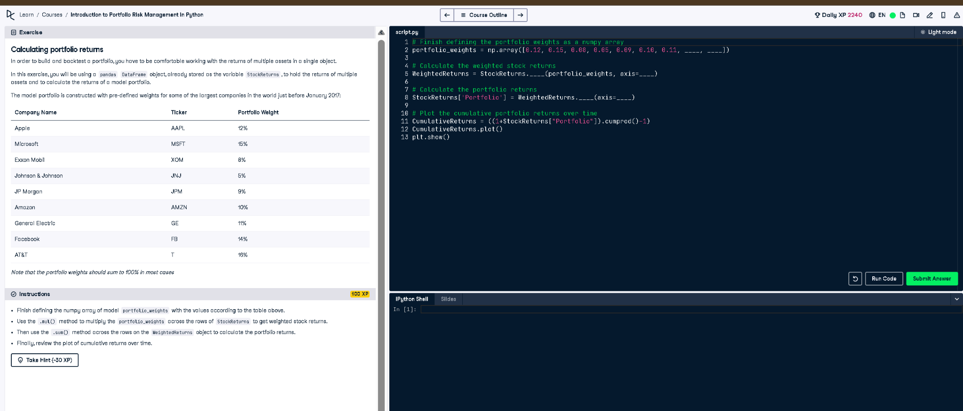
Figure: Exercise prompt and code editor

Full Python Code
# Finish defining the portfolio weights as a numpy array
portfolio_weights = np.array([0.12, 0.15, 0.08, 0.05, 0.09, 0.10, 0.11, 0.14, 0.16])
# Calculate the weighted stock returns
WeightedReturns = StockReturns.mul(portfolio_weights, axis=1)
# Calculate the portfolio returns
StockReturns['Portfolio'] = WeightedReturns.sum(axis=1)
# Plot the cumulative portfolio returns over time
CumulativeReturns = ((1 + StockReturns["Portfolio"]).cumprod() - 1)
CumulativeReturns.plot()
plt.show()

Explanation in Simple Words
This code calculates total portfolio returns using the weighted returns of individual stocks. Each stock's return is multiplied by its weight, summed up, and stored. Then, it computes cumulative returns to show how the investment grows over time. A plot visually displays this performance over time using matplotlib.

